Final Report on

NaturePass Interface Design Process

By Team Nature

Aiman Baig

Jason Huang

Joseph Kolenchery

Derrick Lor

*University of Massachusetts, Lowell*

For

COMP.5270 Human Computer Interaction

Dr. Samantha Reig

April 26, 2024

# **Problem Statement**

The problem displayed in the world of traveling is disconnected experiences from nature. Even with the uprising of social media platforms, there seems to be a lack of applications to share one’s adventurous experience. The current platforms prioritize popular areas which may not even be as nice as displayed on the web. This relays a false representation causing an unpleasant traveling experience from their research. This project aims to fill this gap in the traveling world by designing a traveling journal application that would allow a user to document their trips, share their trip log which includes sites to visit and pictures, and bring in the traveling audience. This design seeks to attract the concept of journaling to provide a better way for people to connect with nature and unique areas giving a deeper appreciation.

# **[Week 1] Choosing a design problem**

Thus, our design process begins. Our next primary goal is to decide on the design of our interface. From different brainstorming sessions, the team produced multiple product designs which ranged from a simple web application to a pet robot that could help us explore town. We let our imaginations run free during these sessions and wrote all our ideas in Figure 1. From our better judgement, it made more sense to create a mobile application or extend it to a web application. An all-in-one mobile application for seasoned and non-seasoned travelers to journal their trips and review other users’ trips to learn to plan future trips. Before establishing this as our project, we did a few preliminary rounds of surveying friends. Although this was not a major interview, they understood that our current interface is in the same ballpark as Expedia or Make My Trip. What these websites and applications lacked was the authenticity of a user who traveled to these locations recently. From the conversations with friends, they expected a simple, clean user interface (UI), a recent picture to grab attention, and an authentic review from a recent fellow traveler. Not an archived review from past years.

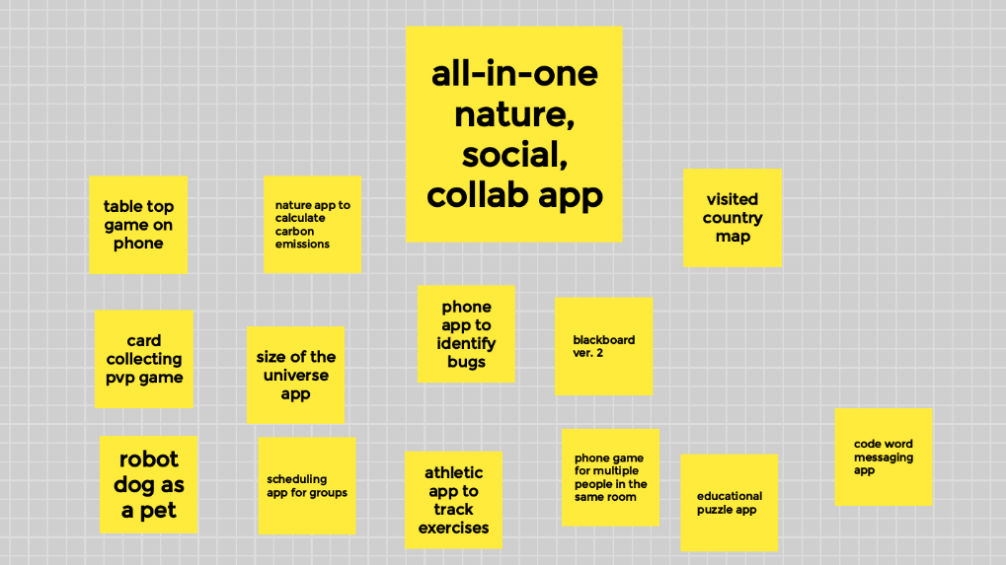

Figure 1. Picture of Google Jamboard with all interface ideas the team had brainstormed.

# **[Week 2] Conduct needfinding research**

Among the needfinding methods introduced in class, we believed contextual inquiries would give the best feedback on how to design the interface for our application. All interviewees were asked for consent and interviews were conducted in a semi-structured manner. The interviewees were not told exactly what our application would be, just a vague context of our approach for designing an application revolving around nature and outdoor traveling. Two major primary stakeholders came from Aiman and Joseph’s needfinding interviews. Aiman interviewed a traveling business friend, to get the perspective of a veteran traveler as shown in Appendix B. Aiman’s business friend travels a lot for work and enjoys exploring in his free time. Thanks to his firsthand experiences as such, it helped us understand what can be useful to this traveling crowd, while Joseph interviewed his computer science friends to get their perspective on the user interface design. These interview questions can be found in Appendix A. It is not a complete list since the interview was semi-structured and varied from interviewee to interviewee. One specific question was, “If you were browsing on the app, what features would you expect it to have?” This question allowed us to understand the interviewee’s mental model of the interface and their own vision of what the perfect travel app would look like. Many answered with the ability to create their trips and optimize satisfaction by visiting as many hidden gems as possible within their agenda.

# **[Week 3] Define tasks**

After everyone interviewed at least one person, be it a friend or family member, we were left with a large set of answers. The answers we received from our interviews held valuable information but were lengthy and extensive. It needed to be distilled into an easily readable format. To remedy this, each team member refined their interview answers into multiple white notes. Each white note encapsulated a single idea so that it was easily digestible and identifiable. All the notes were gathered into an affinity diagram, Figure 2, to help identify the tasks our interviewees expected the interface to have.

The groupings and themes were not created beforehand, and the notes gravitated towards each other in similarity. From these groupings, we were able to define the features and tasks that our interface should be able to afford. Further refinement yielded the task mappings, see Figure 3.

After the task mapping and grouping stage, we reduced some of our tasks to allow us to finish the core features in time. We ended up truncating one-third of the branches and abandoned the maps UI completely. We also reduced some of the personalization and customization features, such as friend lists and background theme options, which could be a future possibility.

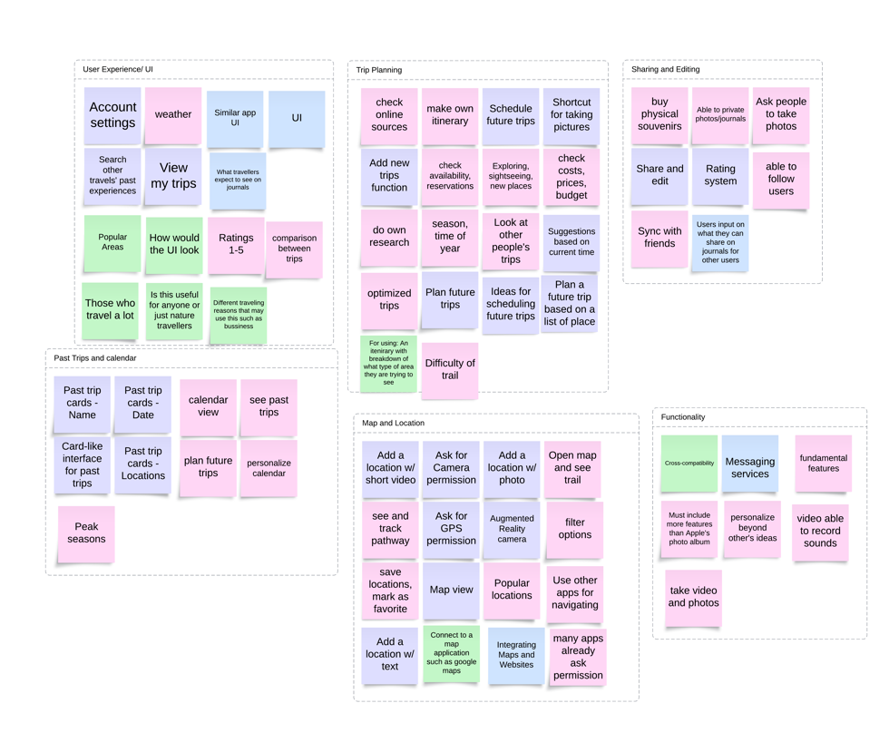

Figure 2. Picture of affinity diagram after notes were grouped.

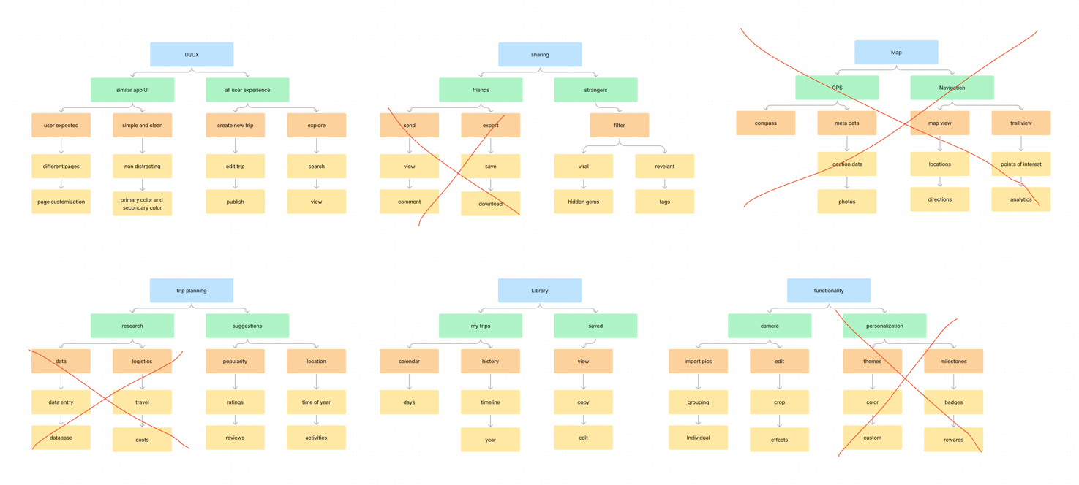

Figure 3. Picture of task mappings each grouping can afford.

# **[Week 4]** **Ideate and create a lo-fi prototype**

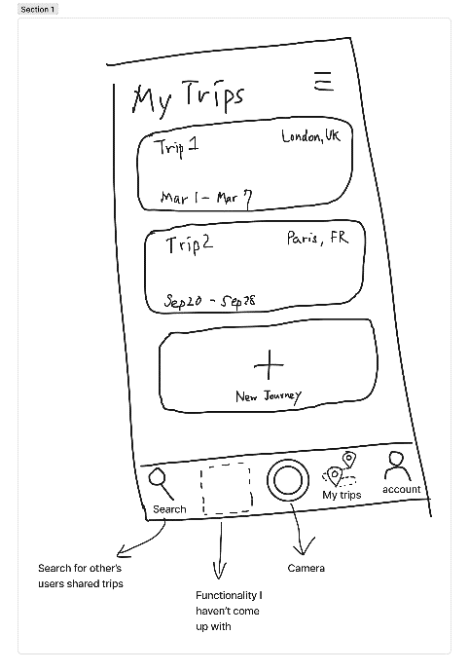

*Figure 4.1. The very first hand-sketched prototype during a brainstorming session. The Home button was added later.*

From these task mappings, the initial lo-fi prototype can be constructed. To accommodate the user needs and the tasks we defined, we figured that we needed a Home page, an Account page for profile management and customization, a Search page for trip sharing and suggestions, a shortcut to turn on the camera, and the My Trips page for user to plan a future trip or keep their past experiences as a journal. All these crucial pages were placed in the navigation bar for easy access. Next, we started to ponder what kinds of layouts could yield the most effective and most organized trip journal entries on the My Trips page, which brought us to this card-like layout as shown in Fig 4.1, and remained the main concept of our designs. We later realized that it was necessary to separate the past trips and future trips, so we added this function while working on the hi-fi prototype.

As we slowly worked toward the details of the unique features, we started to conceive a more “polished” lo-fi prototype which is more than just hand sketches and has some basic interactive elements and animations. In this stage, we started to apply some of the fundamental principles of design to some of our pages, such as Affordance, where users are not allowed to proceed when crucial information is missing, or Signifiers, where users are told that there are no trips and how to add a new one.

*Figure 4.2. The screenshots of the more polished lo-fi prototype*

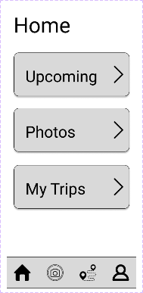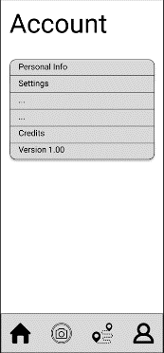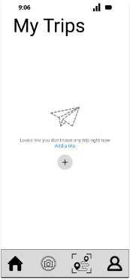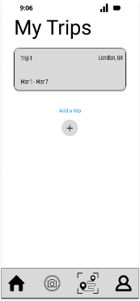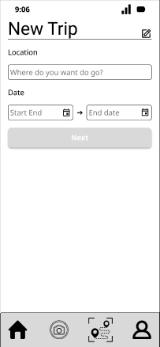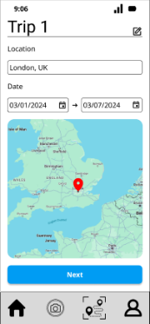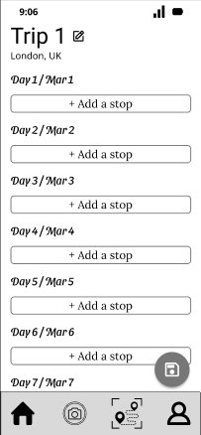

After the mid-project presentation feedback, Professor Reig suggested that we scale down some of the features that might not be implemented in the time available. Thus, we decided to remove the Search page and Camera page. However, the Search page came back revamped as the Explore page later in our final design (It was difficult to foresee what got to leave or stay!).

# **[Week 5]** **Evaluate and refine**

Then we began supplemental rounds of user testing with more specificity on the interface interaction. “Are you guys missing something?” is a question we faced throughout the evaluation amongst friends and different participants. Everybody observed our application's ability to plan trips for their next vacation but also reminded us to include the ability for users to explore the suggestions of others. It was the Explore page and the Suggestions page. We reinvented the Explore page in the form of a social media feed that incorporates features like sharing, trending, and filtering trips. The explore page allowed users to take inspiration from other users’ content to help plan for future trips.

In addition, we evaluated our lo-fi design using Jakob Nielsen's 10 heuristics and found that the interface had usability issues with user help, documentation, and problems in error recovery and prevention. Now on the front page, we included the help, info, and contact documentation pages. The help page includes frequently asked questions along with answers, info describing the purpose of the interface and the problem it tries to solve, and finally, the contact page includes information about us. We also added the ability for users to recover their accounts if they lost their usernames or passwords if they remember the email tied to the account.

From the feedback, we focused on refining our prototype more than adding additional features. A lack of skill in using Figma was also a reason to slow down the addition of features. Feedback from Professor was also the same and we knew it was the right way to go. This led to the hi-fi prototype from the feedback we received.

# **[Week 6]** **Finalize a hi-fi prototype**

We finalized NaturePass as the name for our design interface. We implement the hi-fi prototype to provide an image of what the final interface would potentially look like. People can create their user profiles and interact with other users’ trips. The prototype was built on Figma which implements a full-functioning UI for the application to show the appearance to the audience. The interactions between these pages have been fully implemented in the prototype to demonstrate the transitions between different pages such as from home, explore, my trips, and account (see Figures 5, 6, 7, 8).

After setting up an account you are directed to the home page as shown in Figure 5. This figure shows an example of what a user would see when they are on the home page. To expand, they see the explore feed button on the first row, then my photos section from their photo library, and lastly my trips section in the last row. This page was created to be quite simple and give users the ability to directly jump to any part of the interface.

The explore page provides a variety of information based on the search criteria the user would like to travel to. If no criteria are selected, then popular destinations will appear on the vertical scroll feed. This allows users the ability to curate their own experiences or see posts based on others’ experiences. The figure below has a couple of interesting features such as the search and filter options. The search option allows a user to search for a specific area or trip which will then pop up on the page as the example of a park is shown below. The description will provide you with a user's experience as well as pictures. The second feature of a filtering option can help you dig deeper into exactly what a user is looking for on their trip. The figure below shows the filter as a national park, and the user can scroll down and see all the parks in the area.

|  |  |
| --- | --- |
| Figure 5: A display of the Home screen | A screenshot of a phone  Description automatically generated  Figure 6: A display of the explore page with search and filter. |

Users will go to the My Trips page where they will journal their own experience. The prototype allows one to exemplify how a user would interact with NaturePass. Figure 7 shows an example of the Grand Canyon as one’s trip where they may go on and edit their pictures and journals. The users will have the option to put the date of their trip, the images they took, and their writing either as a journal or description of each spot they went to under the images.

|  |  |
| --- | --- |
| Figure 7: A display of the My Trips section of Hi-Fi Prototype | A screenshot of a phone  Description automatically generated  Figure 8: A display of the Account page for Hi-Fi Prototype |

Lastly, the account information is where one may interact with their general profile. The prototype includes the interaction of going to a personal profile, setting, and seeing the version of the app as shown in the figure below. The profile can display the user's profile picture, name, birth date, gender, and the ability to change all fields, including email and password. In the settings pages, we can turn on and off the alerts, sounds, color blindness, and face recognition ability. Finally, the version page would simply display the version the app is currently running on as the software keeps getting updated with new features.

# **[Week 7] Evaluation of Hi-Fi prototype**

Testing was conducted amongst a few friends. A set of heuristic evaluations was laid down (Appendix D) and the participants were asked to interact with the interface and provide their feedback. Starting with the explore page, interviewees liked the minimalistic design and were familiar with a similar design but understood our application focuses on texts much more which was something they expected since it was a journal.

Users found it easy to navigate around to perform tasks like adding a trip and updating a trip with new destinations. It was also visible that users were looking for a few more features like sharing their plans and journals they have reviewed with other users, which is a feature we intend to add in future improvements. Error tracking and management were something we had not planned on testing. Another feedback from the users was about the balance of colors in the interface. An extreme contrast was seen on the interface, and they preferred a softer color balance.

Once evaluation based on heuristics was completed users were asked for their feedback on the application in general and a few things stood out in common. The idea of a journal has a bigger potential than a travel application. “Why can’t this be a journal application for anything and everything.” Users saw the emphasis on text which NaturePass had unlike other applications and shared that if it is scaled to an effective size, it could be a journal application for anything.

The positive and negative feedback from users gave us all insights into what we lacked. Users expected an application with more features for testing. The idea of a journal is what caught the eye of most users. We concluded from these tests that the application needed many more features, and the interface needed to be refined. The scalability of the application is something we could expand upon from these evaluations.

# **Conclusion**

In conclusion, we built NaturePass as an interface that helps travelers be more in-tuned with nature by allowing the facilitation of user-inspired experiences to be created, uploaded, and viewed online. Users can take that inspiration as a springboard to start planning and building future trips. NaturePass fosters a community of nature enthusiasts as well as entry-level beginners to share their love and deepen their connections with the natural world. Untold adventures and hidden experiences await you in NaturePass.

**Appendices**

**Appendix A:**

**Samples of interview questions**

* How often do you go on vacation?
* How often do you use mobile apps when traveling?
* Do you have specific destinations you prefer, or do you like to explore?
* What are some of the most important things you consider when planning a trip to a new natural location?
* Do you usually prefer to plan your own itineraries or follow recommendations from others?
* What features are most important to you in a travel app?
* Would you be more likely to use an app that lets you plan your own trips or explore virtual experiences curated by other users?
* If you were browsing on the app, what features would you expect it to have?
* What features from other apps do you like/dislike the most?
* What additional features would make this app more engaging and informative for users?

**Appendix B**:

**Aiman’s Interview**

* Traveled every other week
* The main time to explore is after work from 4 pm to 12 pm
* Enjoys Nature
* Enjoys planning beforehand and saves all spots on Google currently
* Also enjoys taking notes about areas to share with friends or if traveling to the same place again
* From our app idea, he mentioned how he enjoys the idea of pictures and journaling his experience
* Makes it easy to share with his friends
* His main concern was that he wanted simplicity or else it would just be another Expedia or those types of websites

**Appendix C:**

**Joseph’s Interview**

* Travel for leisure
* Prefers peaceful locations away from cities
* Find cost-effective trips
* Expect authentic reviews to explore from users who recently made trips to similar destinations
* Want the freedom to plan their own trips
* Need an application to organize these trips
* Ability to plan with a group
* Expect a simple organizer/planner app that allows you to go through other users' journals and not promotions or advertising

**Resources**

“Expedia Travel: Vacation Homes, Hotels, Car Rentals, Flights & More.” Expedia.com, www.expedia.com/. Accessed 26 Apr. 2024.

“The Collaborative Interface Design Tool.” Figma, www.figma.com/. Accessed 26 Apr. 2024.

MakeMyTrip USA - #1 Travel Website for Flight Booking, Airline Tickets, www.makemytrip.com:443/. Accessed 26 Apr. 2024.

Nielsen, Jakob. “10 Usability Heuristics for User Interface Design.” Nielsen Norman Group, 20 Feb. 2024, www.nngroup.com/articles/ten-usability-heuristics/.